**Lab 8. Two inputs Logic gates**

**Question 1. Create the AND gate**

1. **Parts：**

two 1N4148 Diodes (**D1&D2 in the diagram**)

one 1KΩ Resistor (Brown, Black, Red) (**R0 in the diagram**)

several solid wires

built-in logic probe

1. **Schematic diagram of AND gate:**

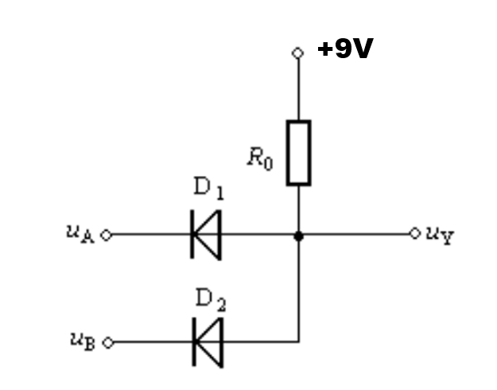

* 1. Diode 1N4148:

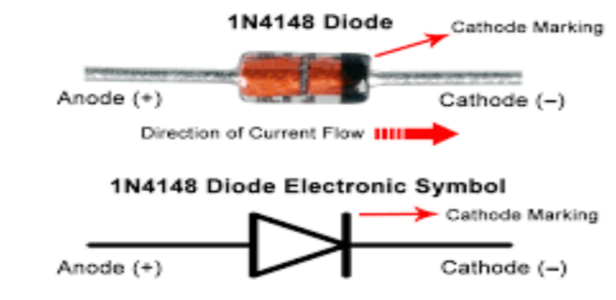

* 1. uA and uB the inputs of the system.

Connect any input to the positive bus strip as input is 1.

Connect any input to the negative bus strip as input is 0.

* 1. uY is the output the logic gate. In order to probe the output, touch the tip of logic probe to the bare end of the output wire. See an example below:

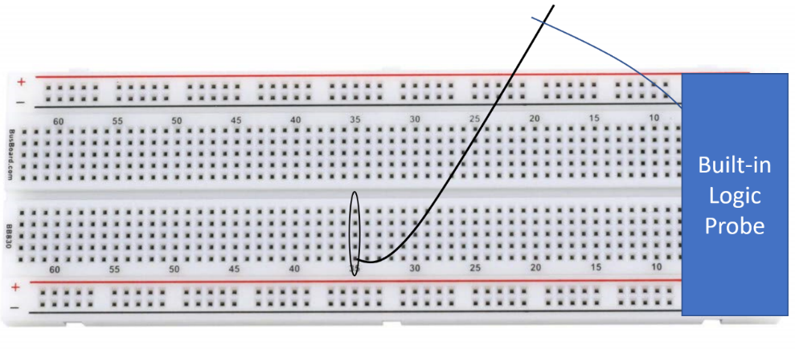

If you want to measure the voltage in down column 35(the area is circled), you can plug a solid wire in any socket of that column and use the tip of built-in probe touch the bare end of the output wire, observe the light changing of LEDs.

1. **Requirement:**

Based on the schematic diagram of AND gate, make the connection on the breadboard. **After checking the connection, connect the switch wire goes to the negative terminal of the battery.** Demonstrate the output corresponding to 4 different combinations of inputs.

**Question 2. Create the OR gate**

1. **Parts：**

two 1N4148 Diodes (**D1&D2 in the diagram**)

one 1KΩ Resistor (Brown, Black, Red) (**R0 in the diagram**)

several solid wires

built-in logic probe

1. **Requirement:**

Refer to the schematic diagram of AND gate, **first draw the circuit diagram of the OR gate on the paper and show it to me**, then make the connection on the breadboard and demonstrate the gate is functional.

**Question 3. Design circuit based on truth table**

**Requirement:**

Below is the truth table of a circuit, inputs are X and Y, output is F.

Refer to lab4 NOT gate, think about how to design this circuit. **First draw the circuit diagram on the paper and show it to me. Then I’ll show you the specification of the components(for example the resistance of the resistor)**, then make the connection on your breadboard and demonstrate your result to me.

***If you finish it in class, no submission is needed. Otherwise, you need to take the pictures to prove your results and uploaded them to canvas. You need to take the picture of the results of LL, LH, HL, HH input combinations. L-low, H-high. Later, I’ll create a submission portal in canvas.***